

Lab Manual
Subject: Programming of AI

By
Muhammad Zain 2023-BS-AI-052
Semester 5TH-A
Course Code AI-212
SUBMITTED TO Sir Samraiz
The University of Faisalabad Bachelors of Science in Artificial Intelligence
DEPARTMENT OF COMPUTER SCIENCE

────────────Table of Contents────────────
Lab # 1: Programming Fundamentals 1
Lab # 2: OOP 40
Lab # 3: NumPy 98
Lab # 4: Seaborn, Matplotlib, Sklearn 122

LAB-1
“Programming Fundamental”

Q1. Banking Transaction Validator with PIN
Create a bank ATM simulation system.
- The user enters a 4-digit PIN (validate the input).
- Show the account balance and ask how much to withdraw.
- If the amount is valid → subtract it and update the balance.
- If the user enters the wrong PIN 3 or more times → lock the account.
- Use operators to calculate a service charge (2% for each withdrawal).
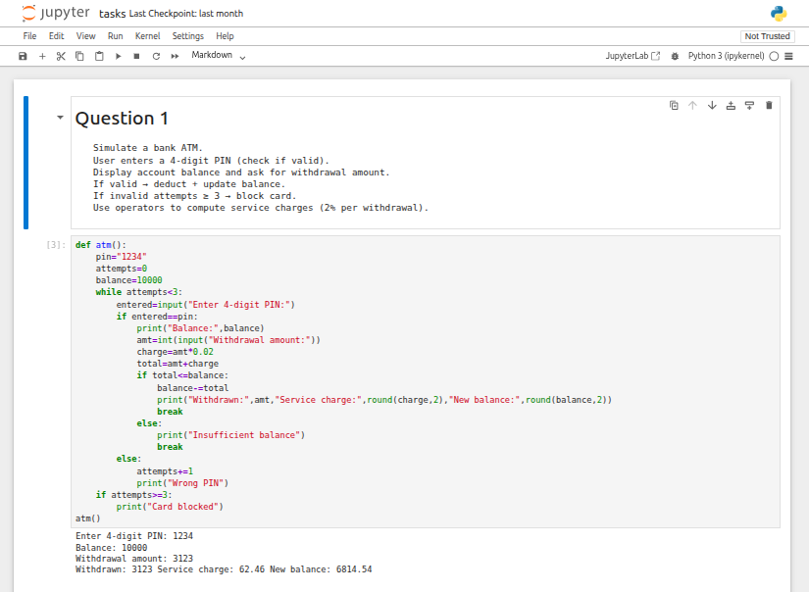

Q2. Grocery Store Inventory System
Create an inventory system using nested dictionaries to store item names, stock levels, and prices.
- The user selects items and enters quantities.
- If stock is available, reduce the inventory accordingly.
- Apply discount tiers (10%, 15%, 20% based on total).
- Display the final bill including 5% tax.
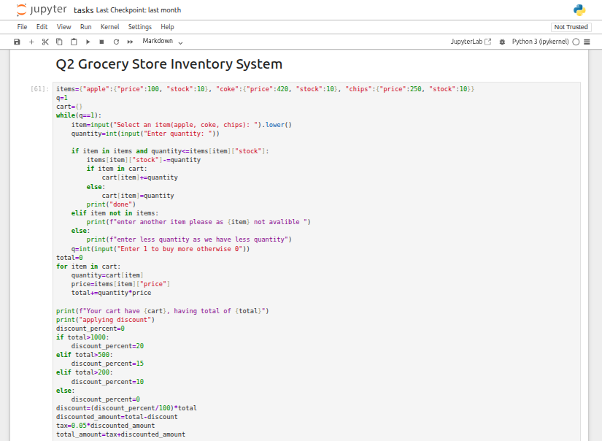
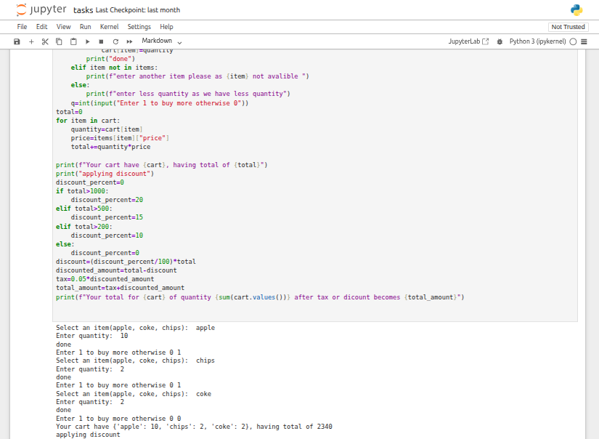

Q3. Student Grading with Subject Weightage
Get marks for 5 subjects where each subject has a different weight (store weights in a tuple).
- Calculate the weighted average.
- Assign a grade (A/B/C/D/Fail) based on performance.
- Check if the student qualifies for a scholarship (≥80% weighted average).
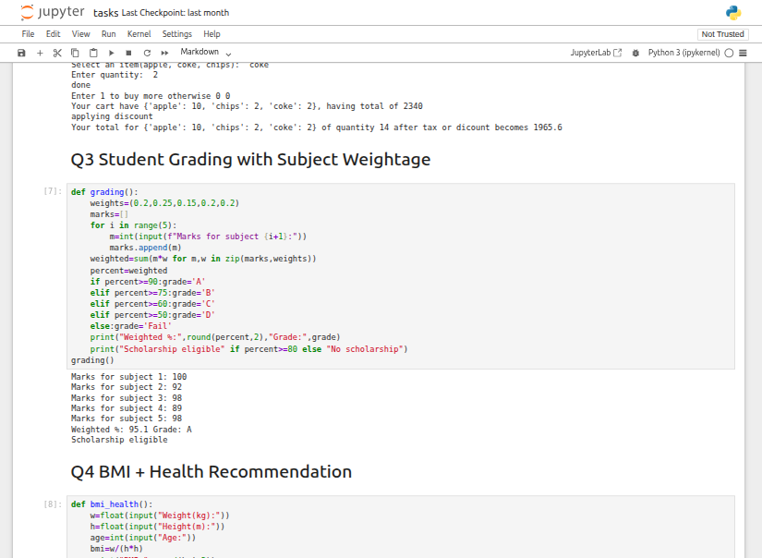
Q4. BMI + Health Recommendation
Expand the basic BMI calculator:
- Accept weight, height, and age as inputs.
- Calculate the BMI value.
- Based on BMI and age, provide personalized health advice (e.g., suggest a diet plan for obesity, recommend exercise for underweight).
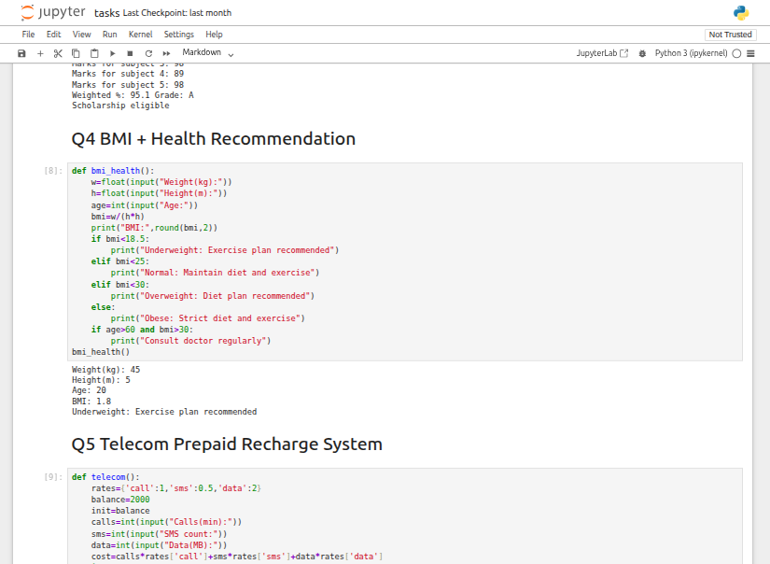

Q5. Telecom Prepaid Recharge System
Store call rates per minute, SMS charges, and data costs per MB in a dictionary.
- The user chooses usage types (calls, SMS, data).
- Deduct charges from the balance accordingly.
- If balance drops below 20% of the starting amount → show a recharge reminder.
- Add bonus balance if the recharge amount exceeds 1000.
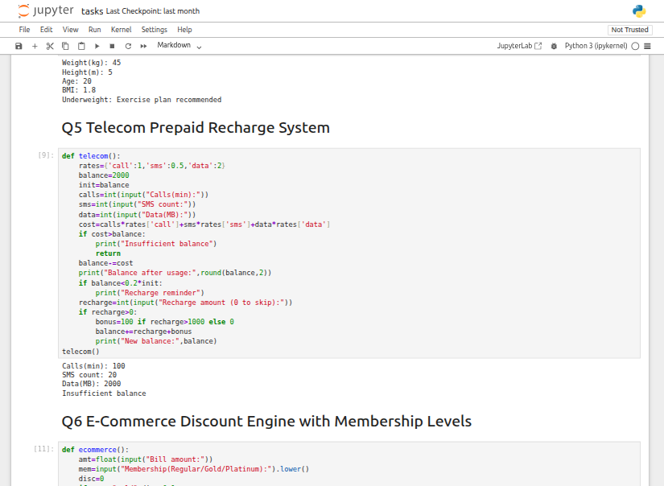

Q6. E-Commerce Discount Engine with Membership Levels
The user enters the bill amount and membership type (Regular, Gold, Platinum).
- Apply different discount rates (Gold +10%, Platinum +15%).
- If the bill exceeds 10,000 → apply an additional 5% discount.
- Display an itemized receipt showing tax breakdowns.
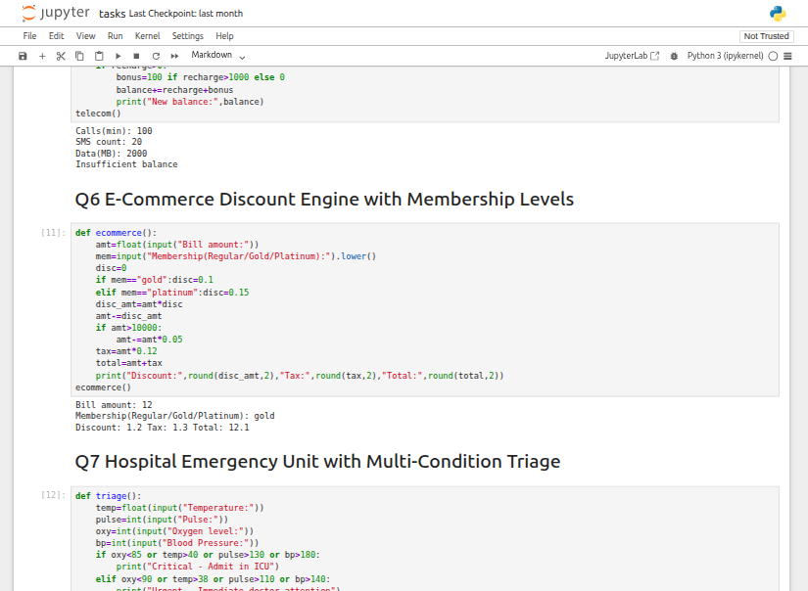

Q7. Hospital Emergency Unit with Multi-Condition Triage
Collect patient vitals: temperature, pulse, oxygen level, blood pressure.
- Classify the patient into categories: Stable, Observation, Urgent, Critical.
- If Critical → recommend "Admit to ICU."
- If Urgent → suggest "Immediate doctor consultation."
- Use nested conditional statements for classification.
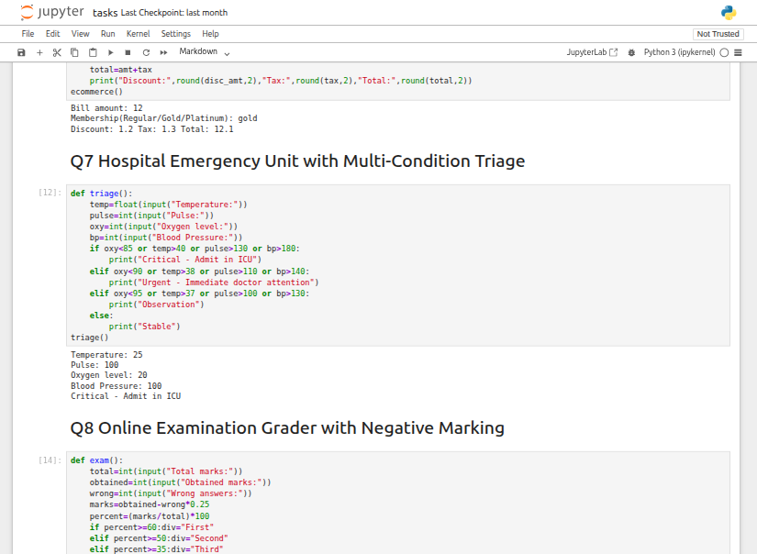

Q8. Online Examination Grader with Negative Marking
Input total marks, marks obtained, and the number of incorrect answers.
- Deduct 0.25 marks for each wrong answer.
- Calculate the percentage score.
- Assign a division and check scholarship eligibility.
- If the student fails → display "Repeat Exam."
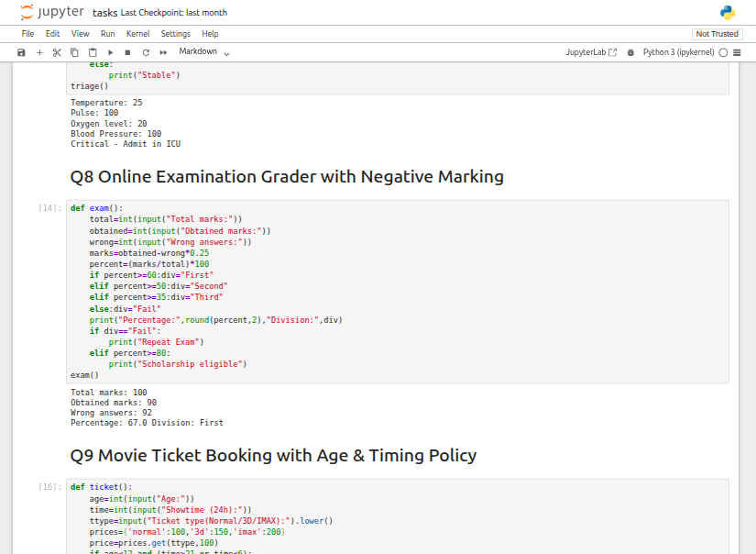

Q9. Movie Ticket Booking with Age & Timing Policy
The user provides: age, showtime, and ticket type (Normal/3D/IMAX).
- Restrict late-night shows for children under 12.
- Apply a 30% senior citizen discount.
- Add a 10% peak hour surcharge when applicable.
- Display the final ticket price.
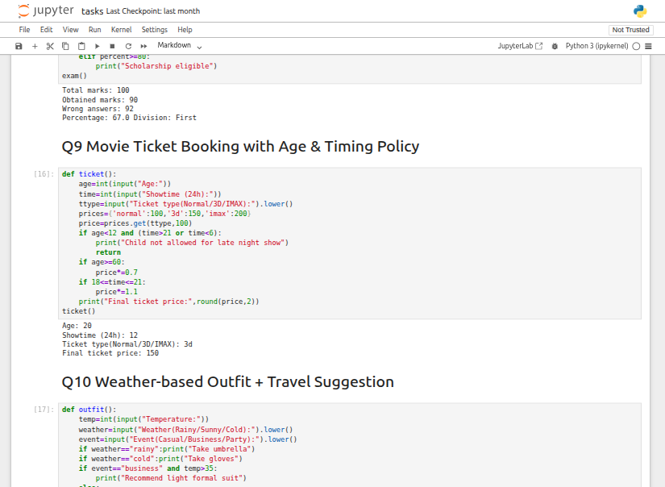

Q10. Weather-based Outfit + Travel Suggestion
Input temperature, weather condition (Rainy/Sunny/Cold), and event type (Casual/Business/Party).
- Suggest appropriate clothing and accessories.
- If Rainy → recommend an umbrella; If Cold → suggest gloves.
- If the event is Business and temperature > 35°C → advise "light formal suit."
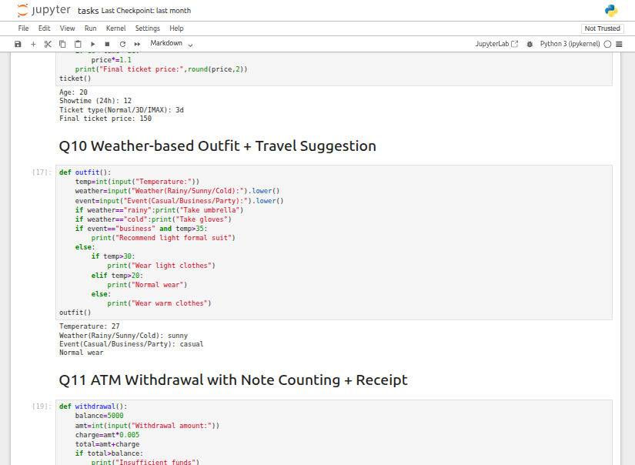

Q11. ATM Withdrawal with Note Counting + Receipt
Accept a withdrawal amount from the user.
- Calculate the minimum number of currency notes needed (1000, 500, 100, 50, 10, 1).
- Apply a 0.5% service charge.
- Print a receipt showing the remaining balance after deduction.
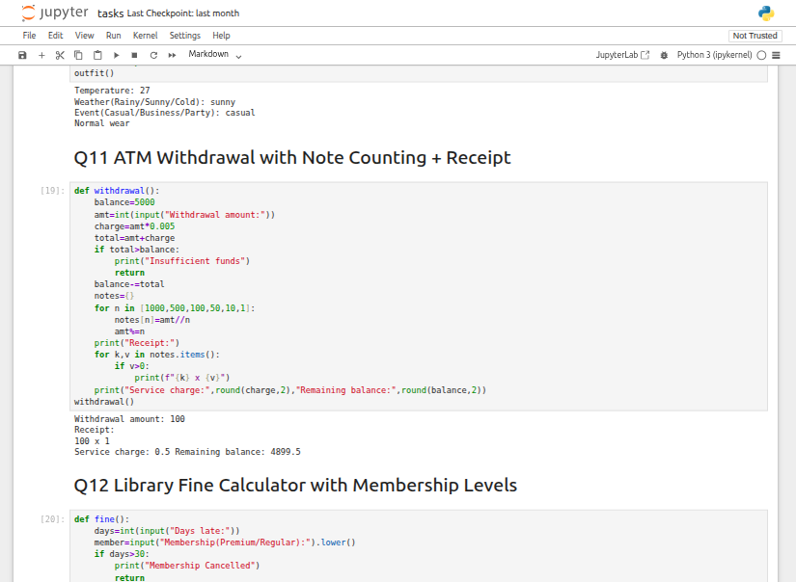

Q12. Library Fine Calculator with Membership Levels
Input the number of days a book is overdue.
- Apply fine rates (10, 20, 50 per day based on delay duration).
- If overdue days > 30 → display "Membership Cancelled."
- If the user has a Premium membership → reduce the fine by 50%.
- Print a detailed fine receipt.
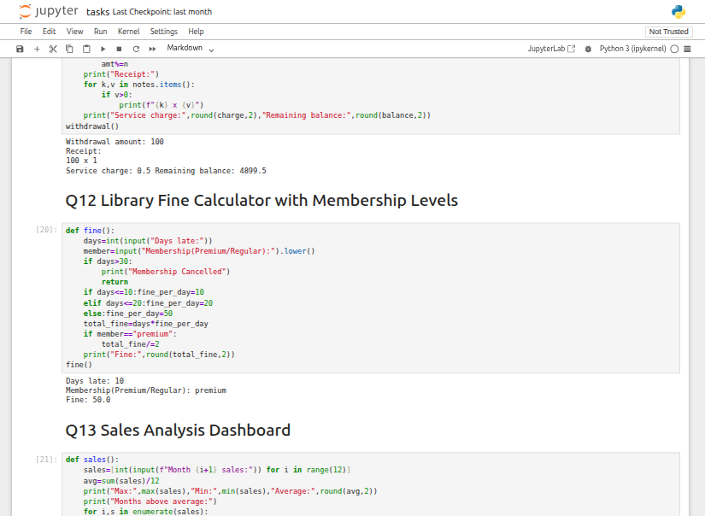

Q13. Sales Analysis Dashboard
Store monthly sales data in a list (12 entries).
- Display the maximum, minimum, and average sales.
- Show which months had above-average sales.
- Use loops and conditions to print "Growth" or "Decline" compared to the previous month.
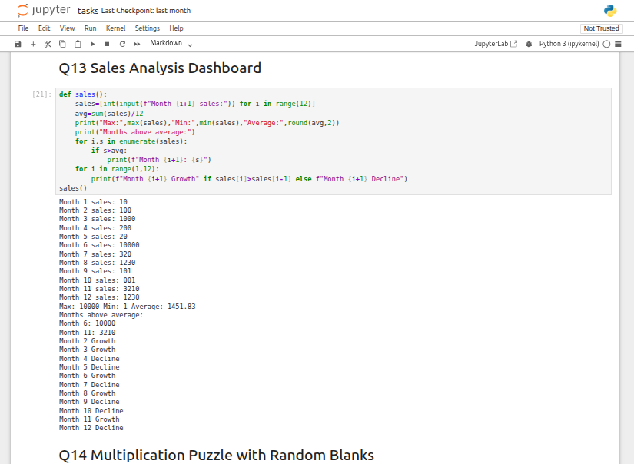

Q14. Multiplication Puzzle with Random Blanks
Generate a multiplication table (1–10).
- Randomly replace 3 answers with "??".
- Ask the user to guess the missing values.
- Track the score and provide a performance comment (Excellent/Good/Try Again).
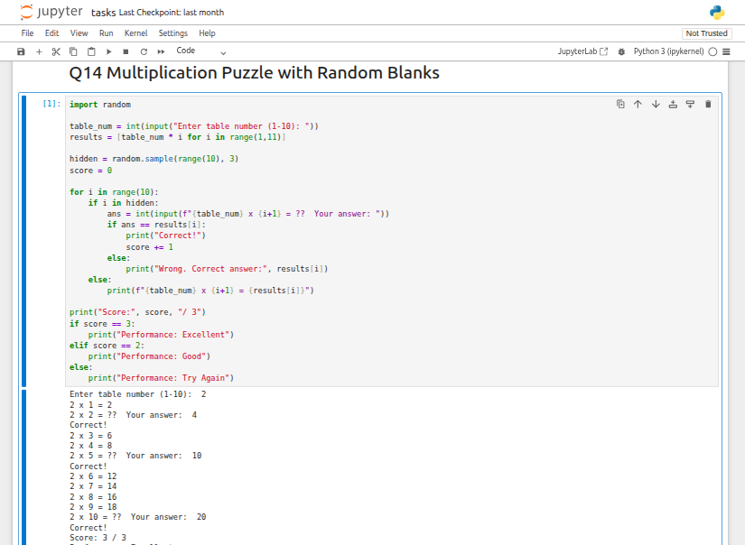

Q15. Password Strength + Re-entry Attempts
Check if the password meets all requirements (length, digit, uppercase, lowercase, special character).
- If the password is weak → ask the user to try again.
- Allow a maximum of 3 attempts.
- If still weak after 3 tries → display "Account Locked."
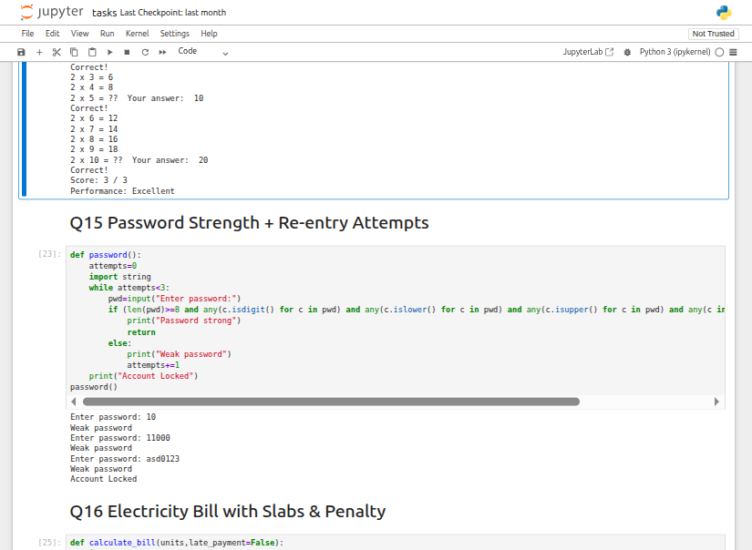

Q16. Electricity Bill with Slabs & Penalty
Create a function calculate_bill(units, late_payment=False):
- Apply tiered rates (5/7/10 Rs based on usage).
- If late_payment is True → add a 15% pena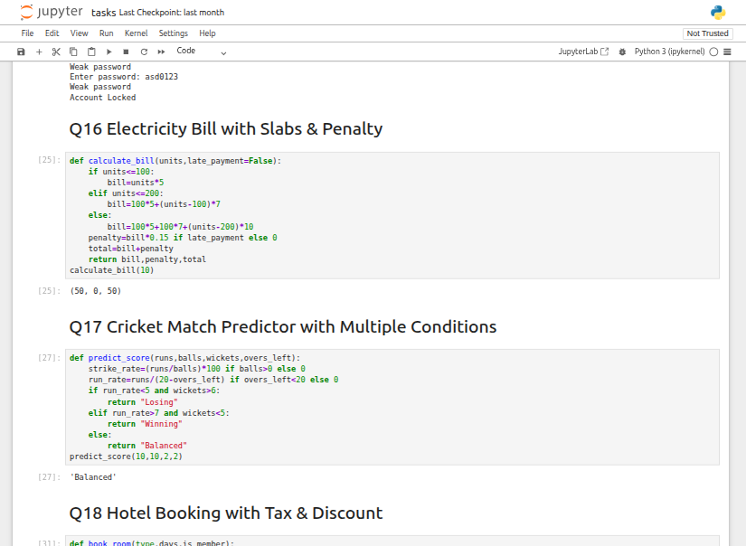

Q17. Cricket Match Predictor with Multiple Conditions
Create a function predict_score(runs, balls, wickets, overs_left):
- Calculate strike rate and run rate.
- If run rate < 5 and wickets > 6 → predict "Losing."
- If run rate > 7 and wickets < 5 → predict "Winning."
- Otherwise → predict "Balanced."
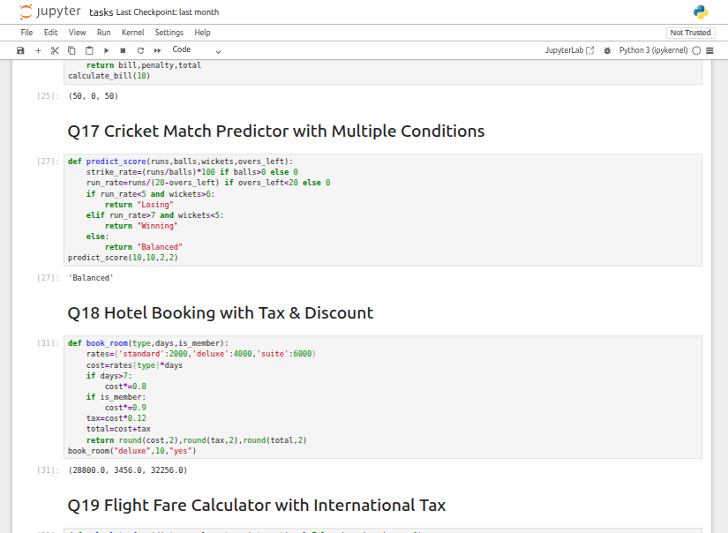

Q18. Hotel Booking with Tax & Discount
Create a function book_room(type, days, is_member):
- Room rates: Standard = 2000/day, Deluxe = 4000/day, Suite = 6000/day.
- If stay > 7 days → apply 20% discount.
- If member → apply additional 10% discount.
- Add 12% tax to the final amount.
- Return a bill slip.
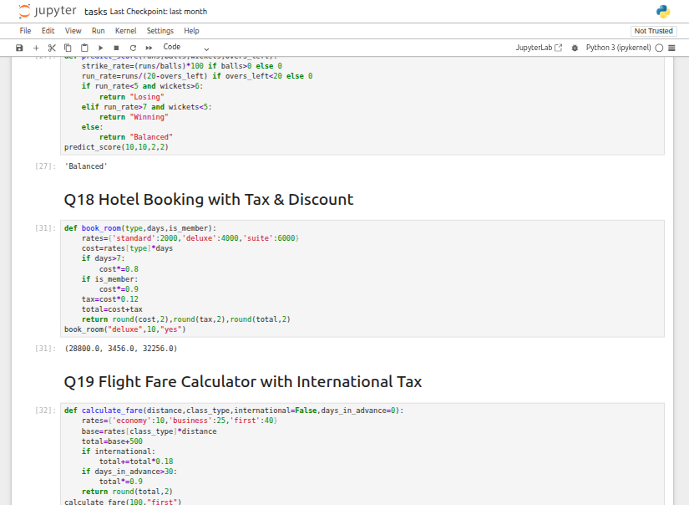

Q19. Flight Fare Calculator with International Tax
Create a function calculate_fare(distance, class_type, international=False):
- Rates: Economy = 10/unit, Business = 25/unit, First = 40/unit.
- Add a 500 Rs fuel surcharge.
- If international → add 18% tax.
- If booked more than 30 days in advance → apply 10% discount.
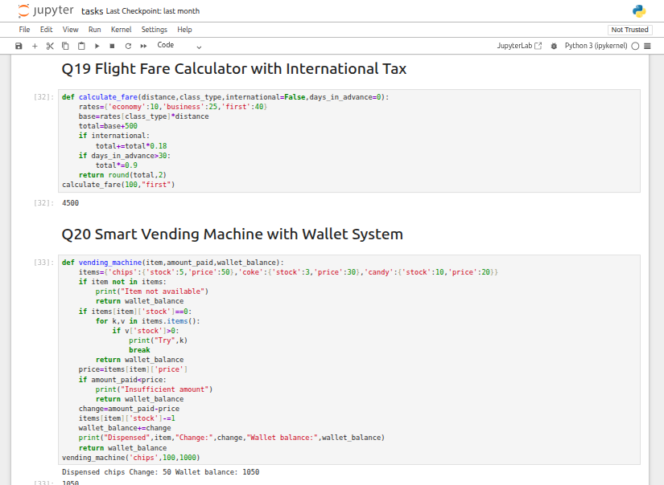

Q20. Smart Vending Machine with Wallet System
Create a function vending_machine(item, amount_paid, wallet_balance):
- Store items in a dictionary with stock levels and prices.
- If payment is sufficient → dispense the item and return change.
- Update the wallet balance.
- If item is out of stock → suggest an alternative.


LAB-2

“OOP”

Q1. Bank Account Class
Build a Bank Account class to represent a bank account.
- Include attributes: account number, account holder name, balance.
- Add methods to: deposit money, withdraw money, display balance.
- Make sure withdrawals cannot exceed the available balance.
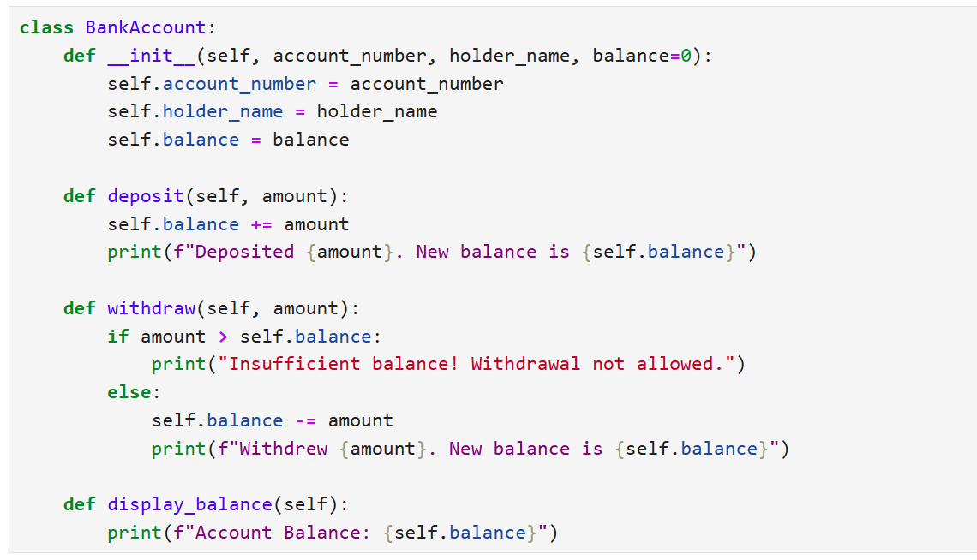
Output:
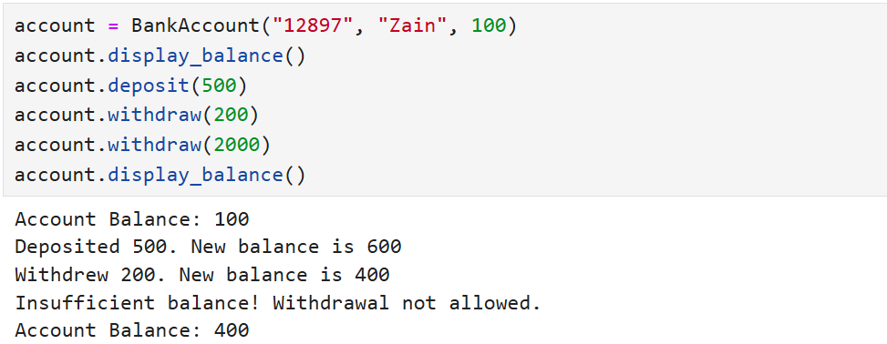

Q22. Book and Library Classes
Design a Book class with: title, author, ISBN, availability status.
- Create a Library class that can: add books, search by title/author, check out books, return books.
- Track which books are currently available.

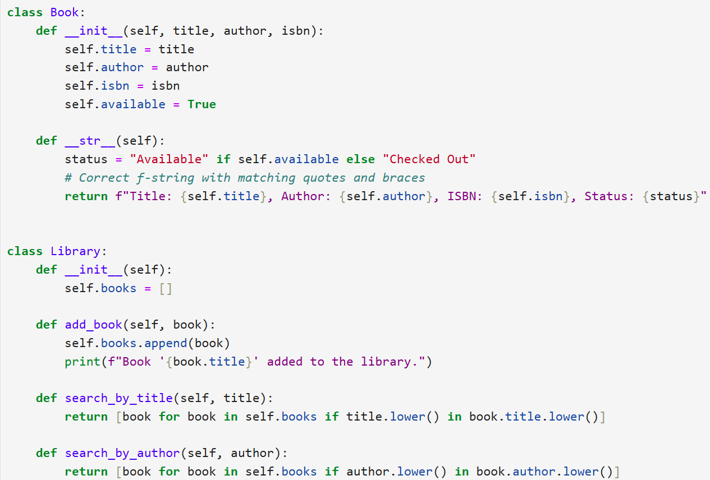
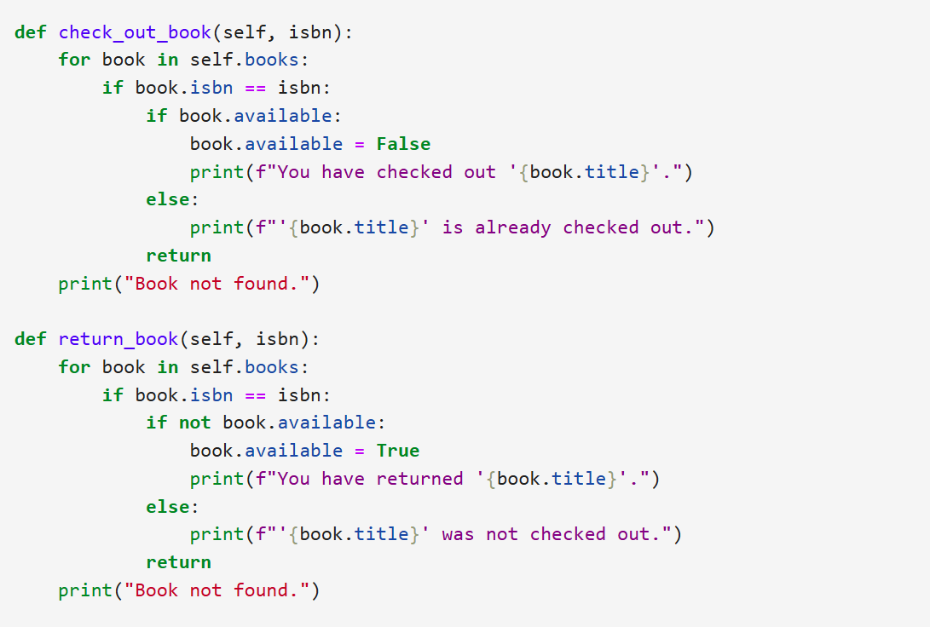

Output:
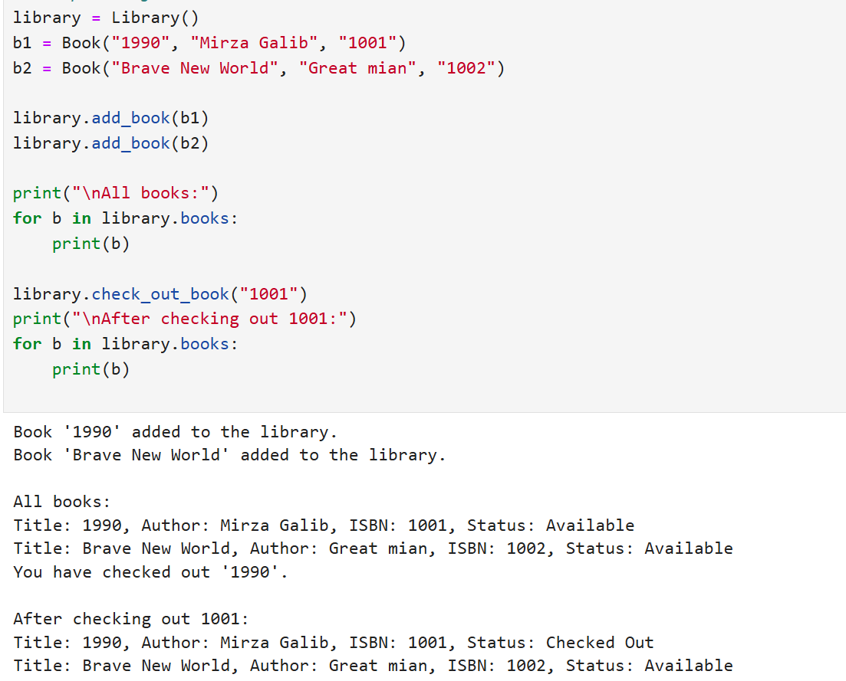

Q23. Student Class with Grades
Build a Student class with: student ID, name, list of grades.
Add methods to: add grades, calculate average grade, determine letter grade.
Include a method to display student info with a performance summary.
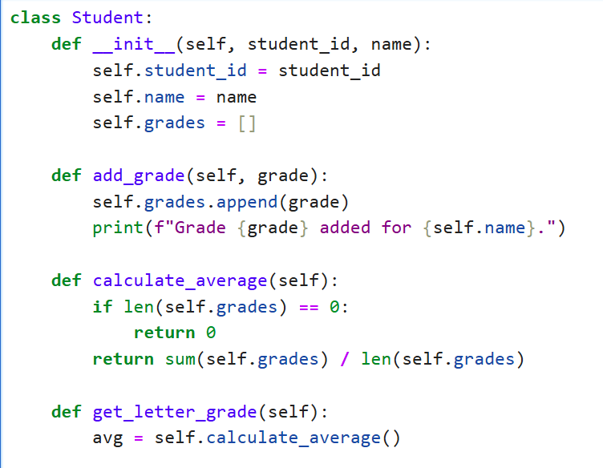
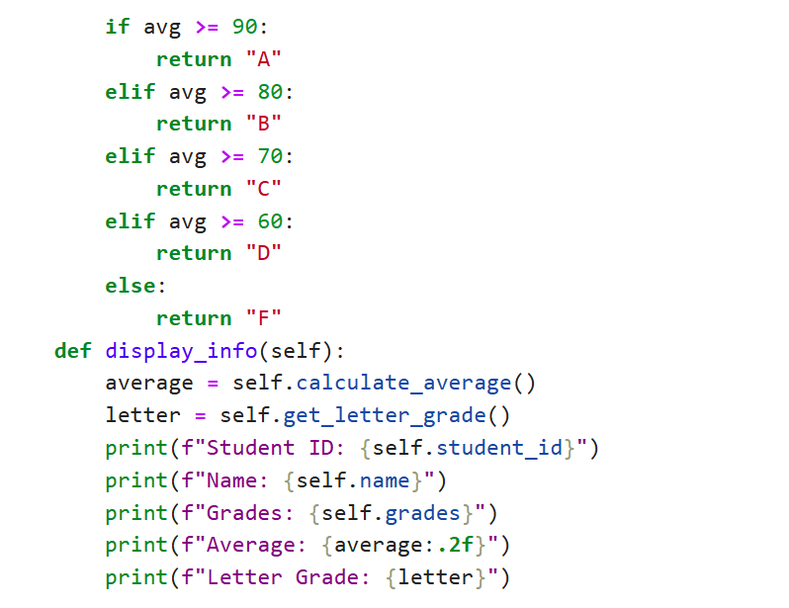
Output:
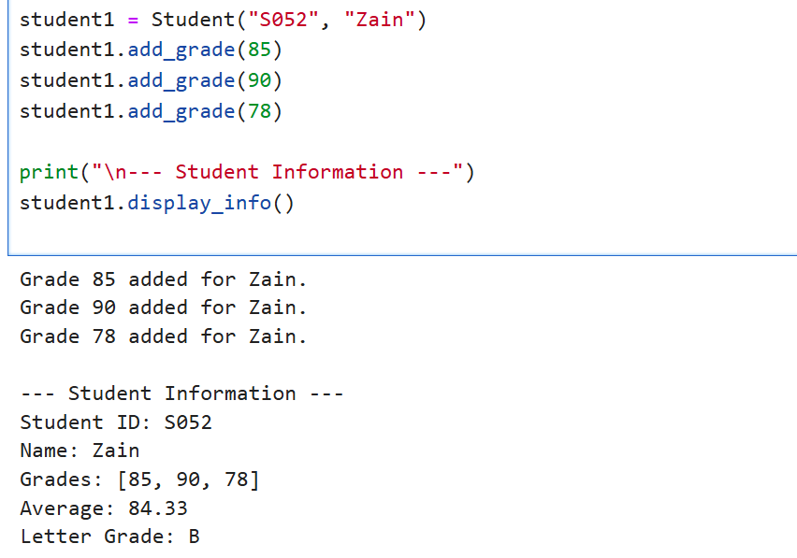

Q24. MenuItem and Order Classes
Design a MenuItem class for food items (name, price, category).
Create an Order class that can: add items, calculate total, apply discounts, generate receipts.
Include tax calculation functionality.
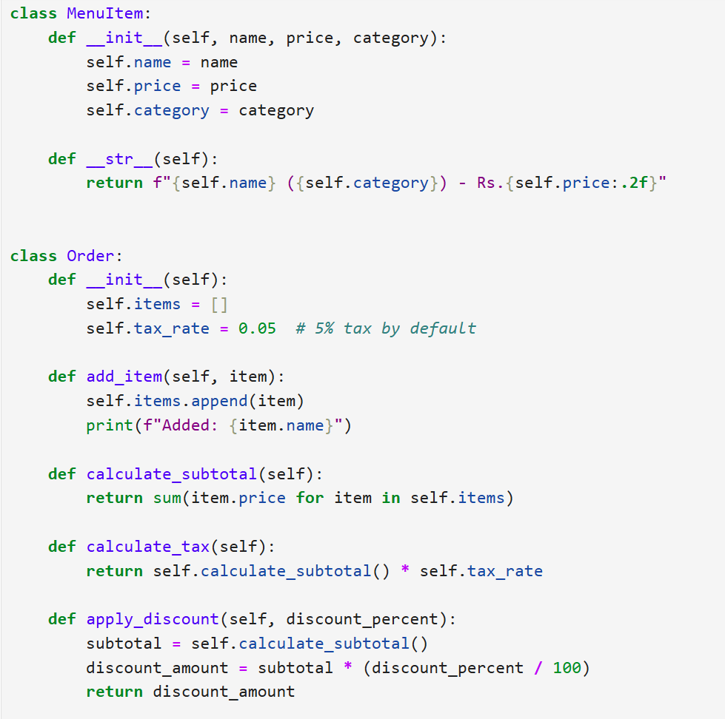
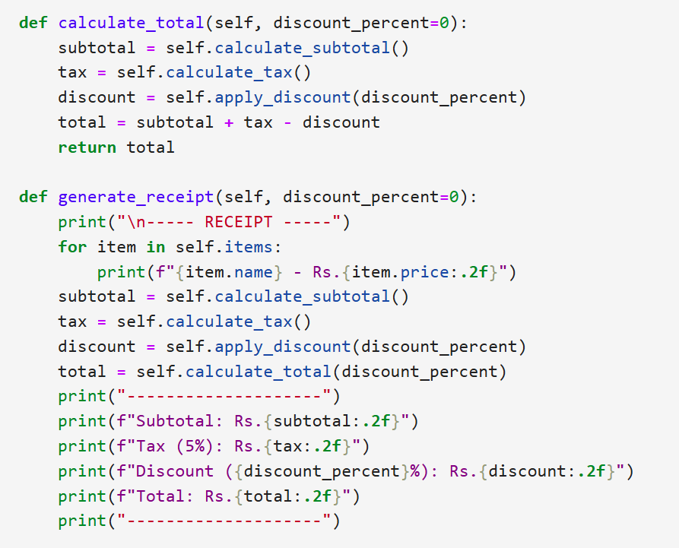
Output:
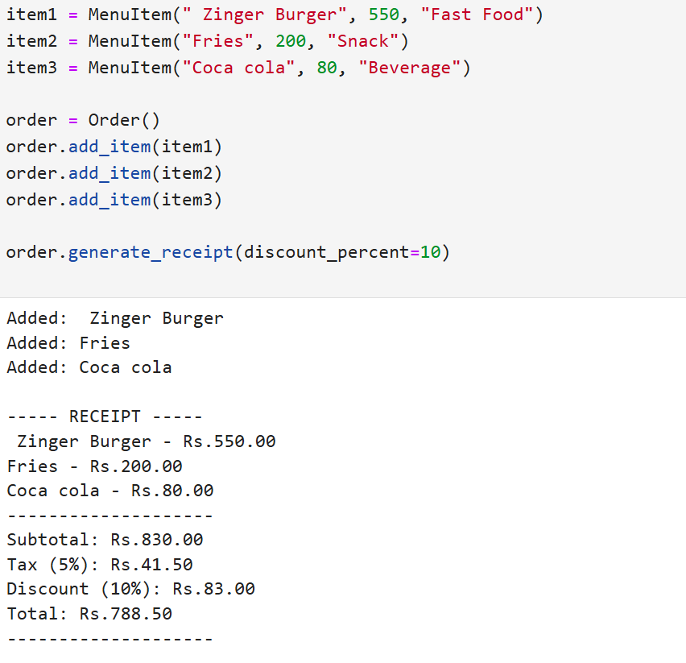

Q25. Vehicle Rental System with Inheritance
Create a Vehicle base class and derived classes: Car, Motorcycle, Truck.
Each vehicle should have: license plate, model, rental price per day, availability.
Build a system to rent vehicles and calculate rental costs.

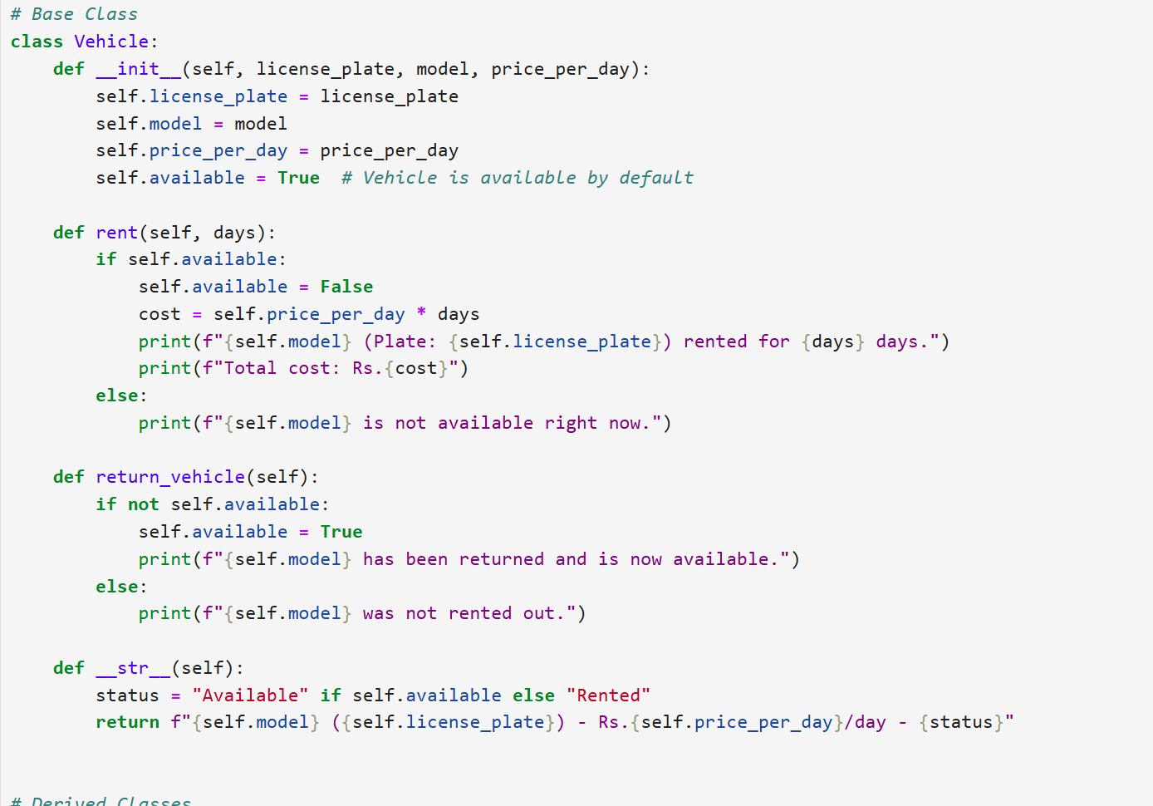
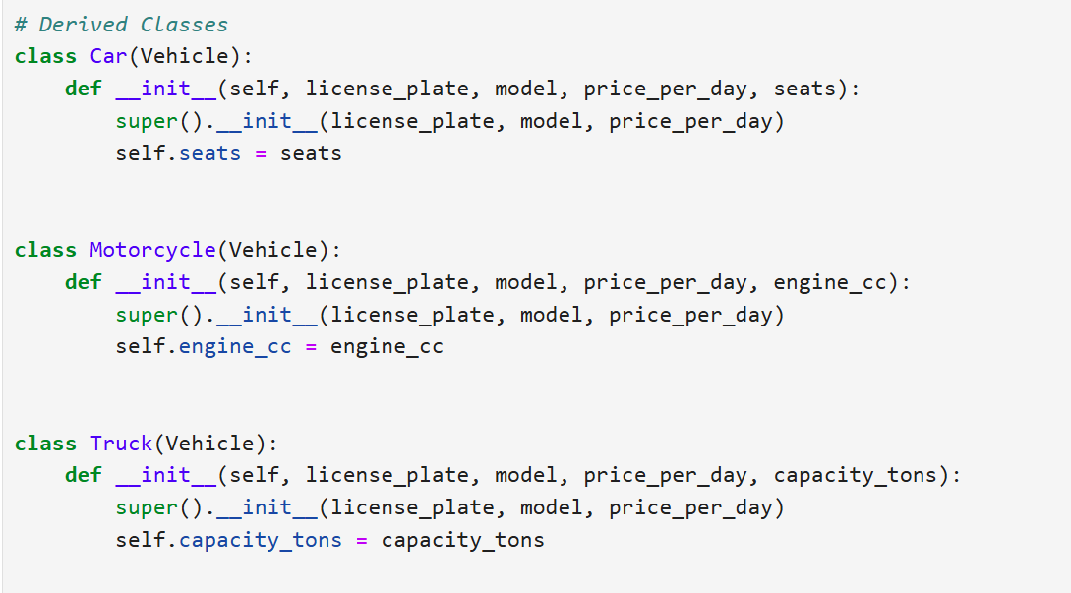

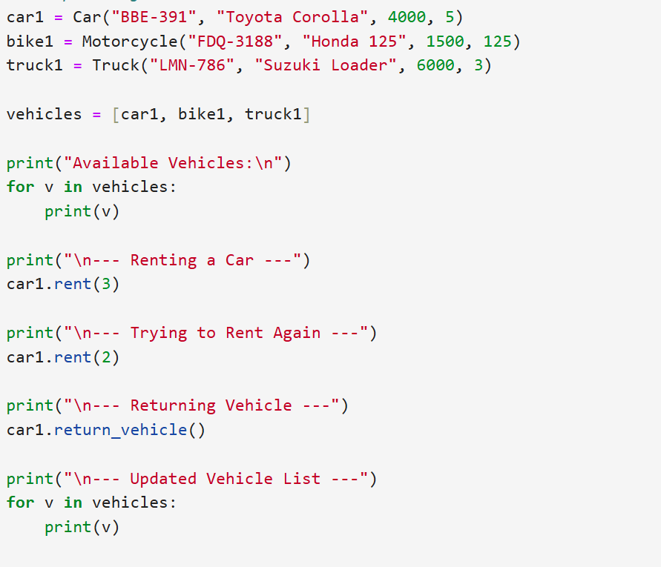
Output:
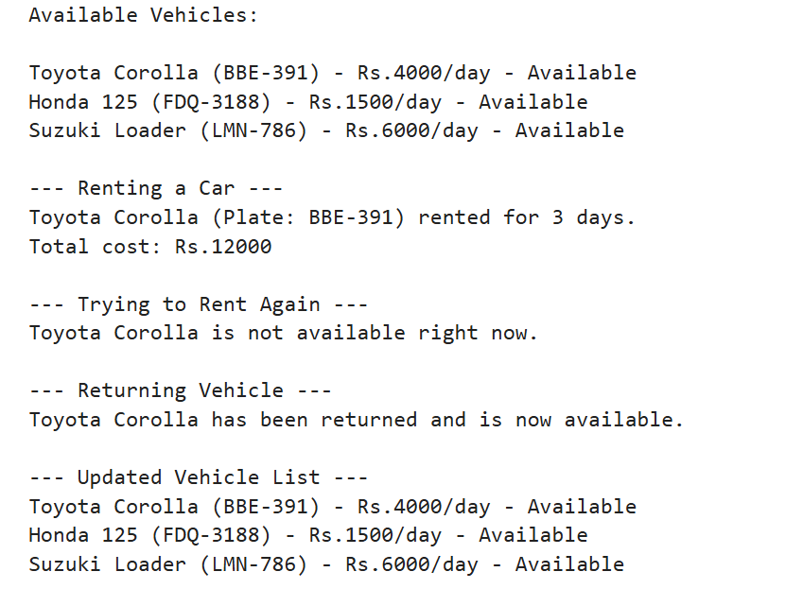

Q27. Product and ShoppingCart Classes
Create a Product class with: product ID, name, price, stock quantity.
Design a ShoppingCart class that can: add products, remove products, calculate total, handle checkout.
Update inventory after checkout.
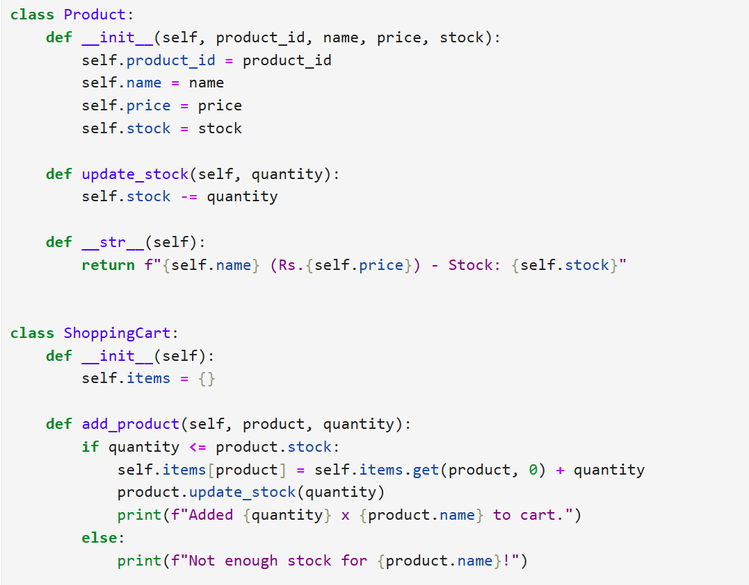
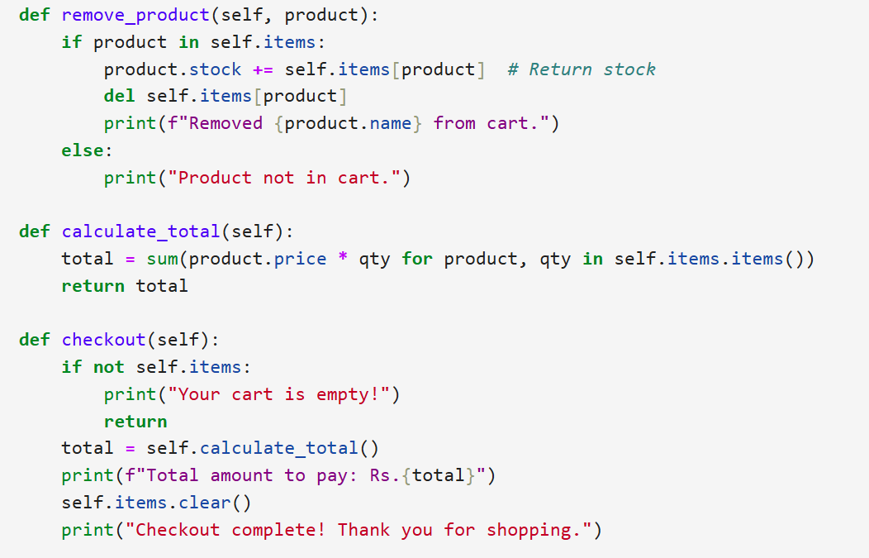

Output:
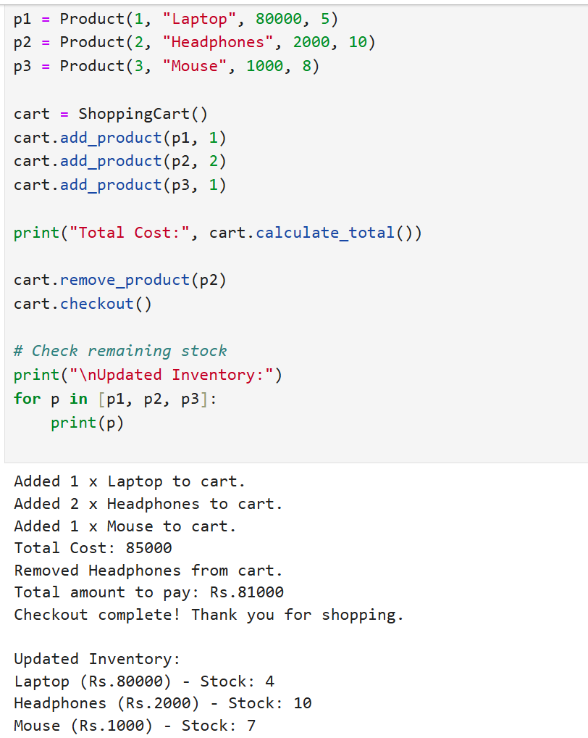

Q28. Patient Appointment System
Design a Patient class to store: ID, name, age, medical history.
Create an Appointment class to manage doctor appointments.
Add functionality to: schedule, cancel, view appointments.

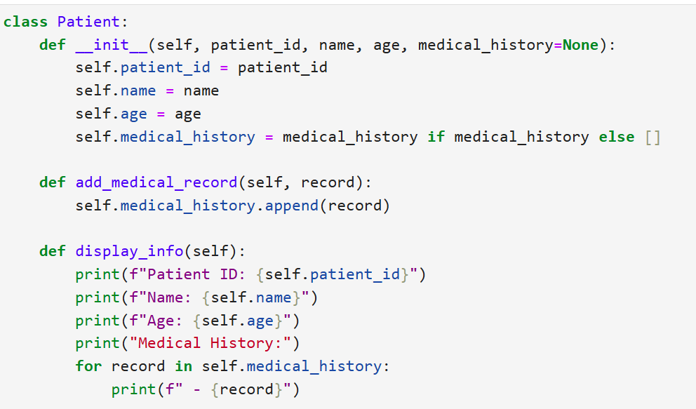
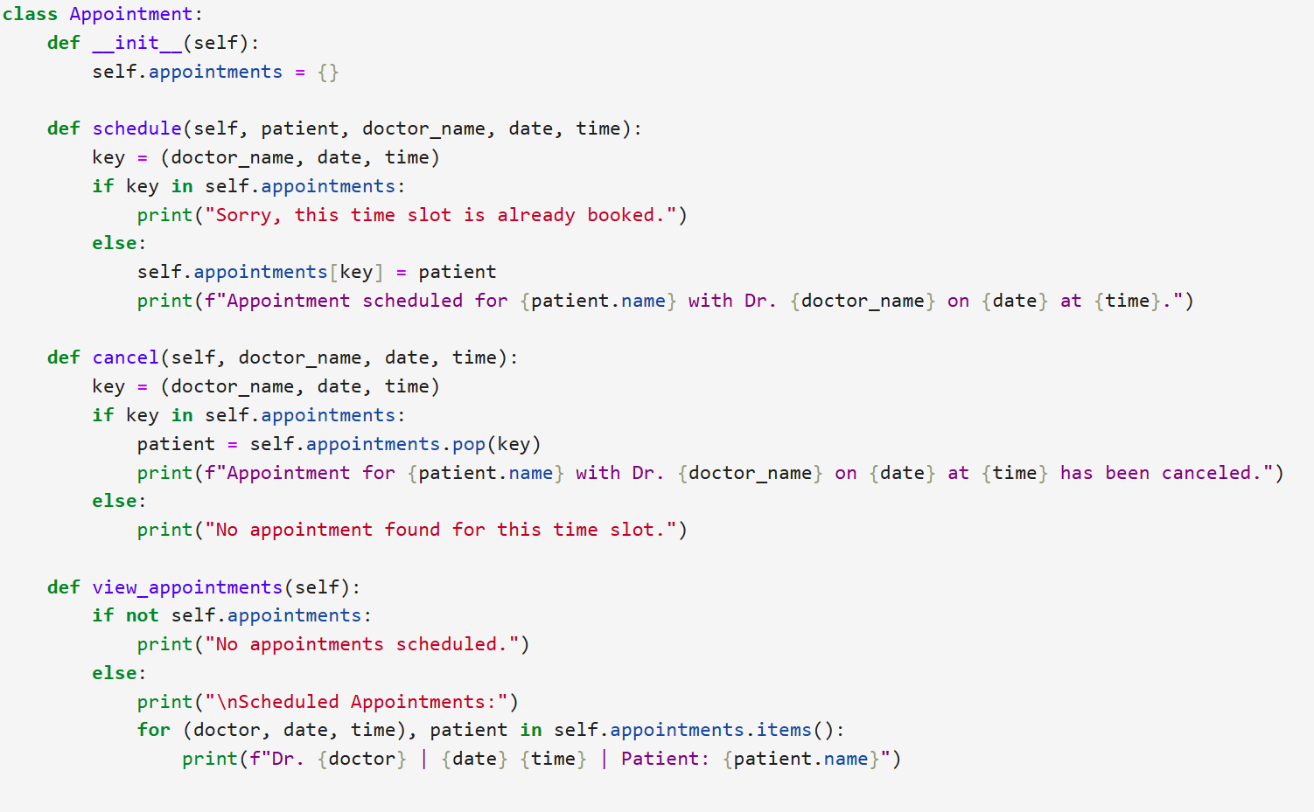

Output:
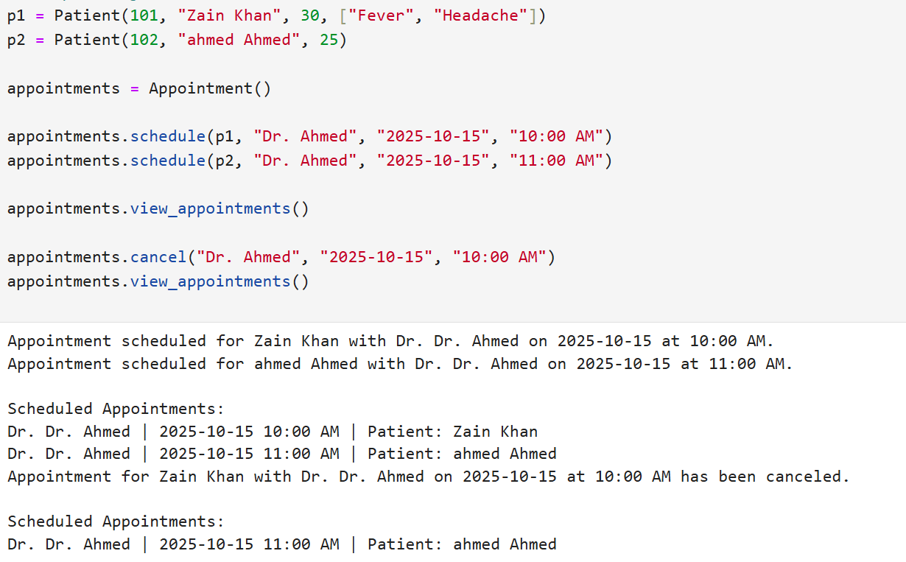

Q29. Social Media User Class
Build a User class with: username, email, friends list, posts.
Add methods to: add friends, create posts, display timeline.
Include privacy settings for posts.
- 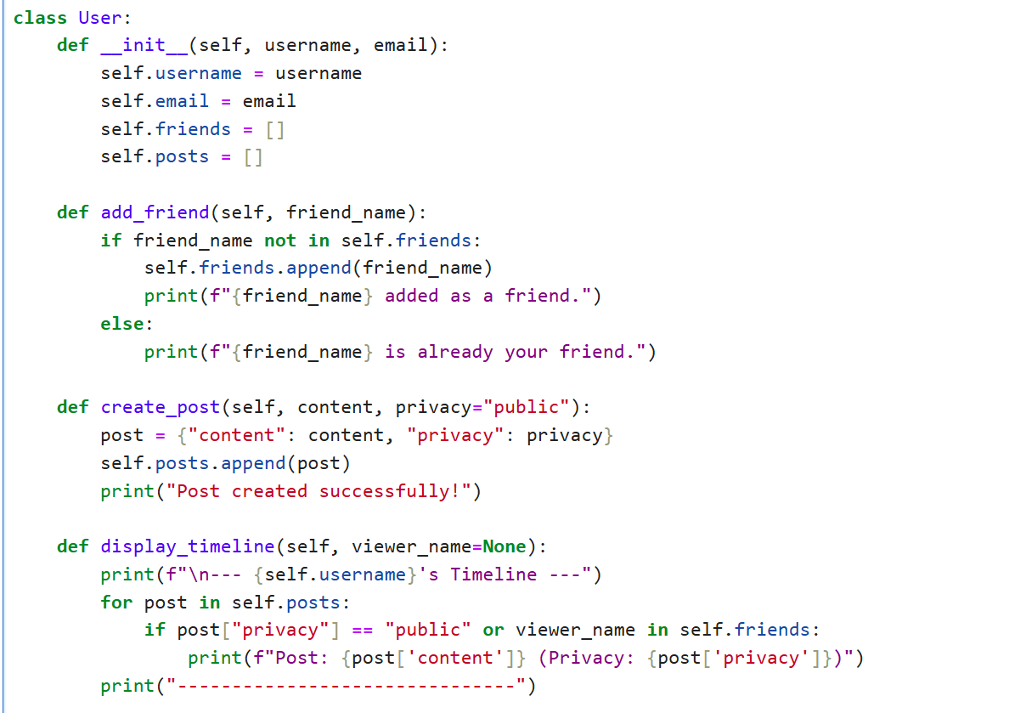
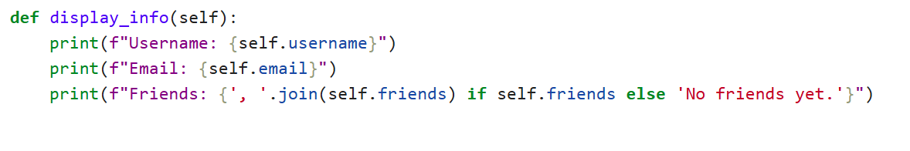

Q30. Hotel Room Booking System
Design a Room class with: room number, type (single/double/suite), price, availability.
Create a Booking class to handle: reservations, check-in/check-out dates, calculate stay cost.
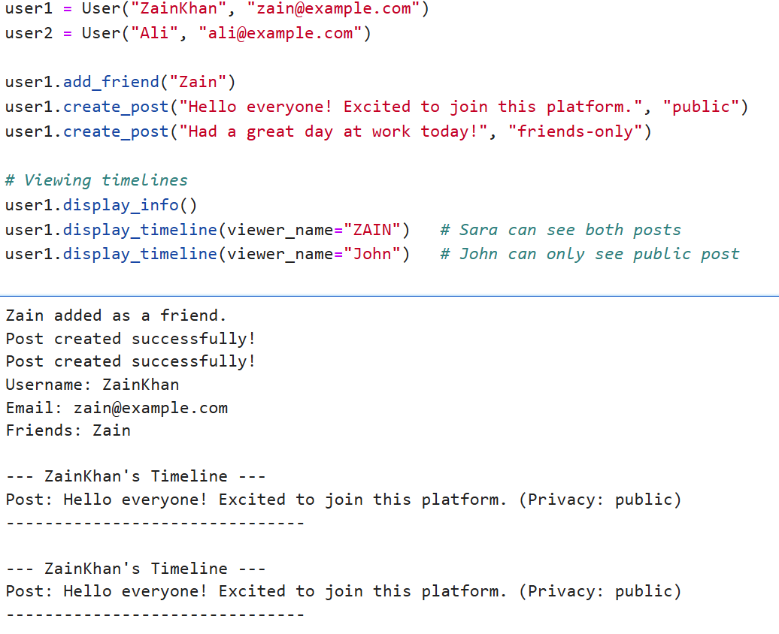

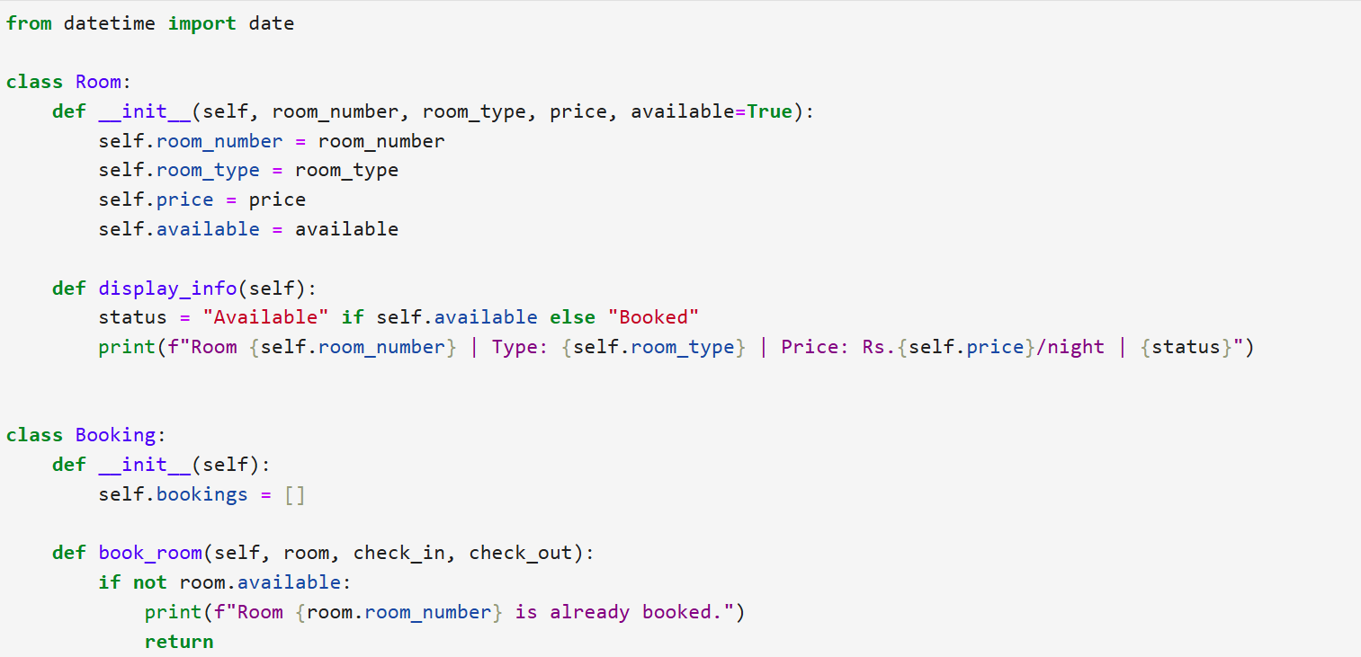
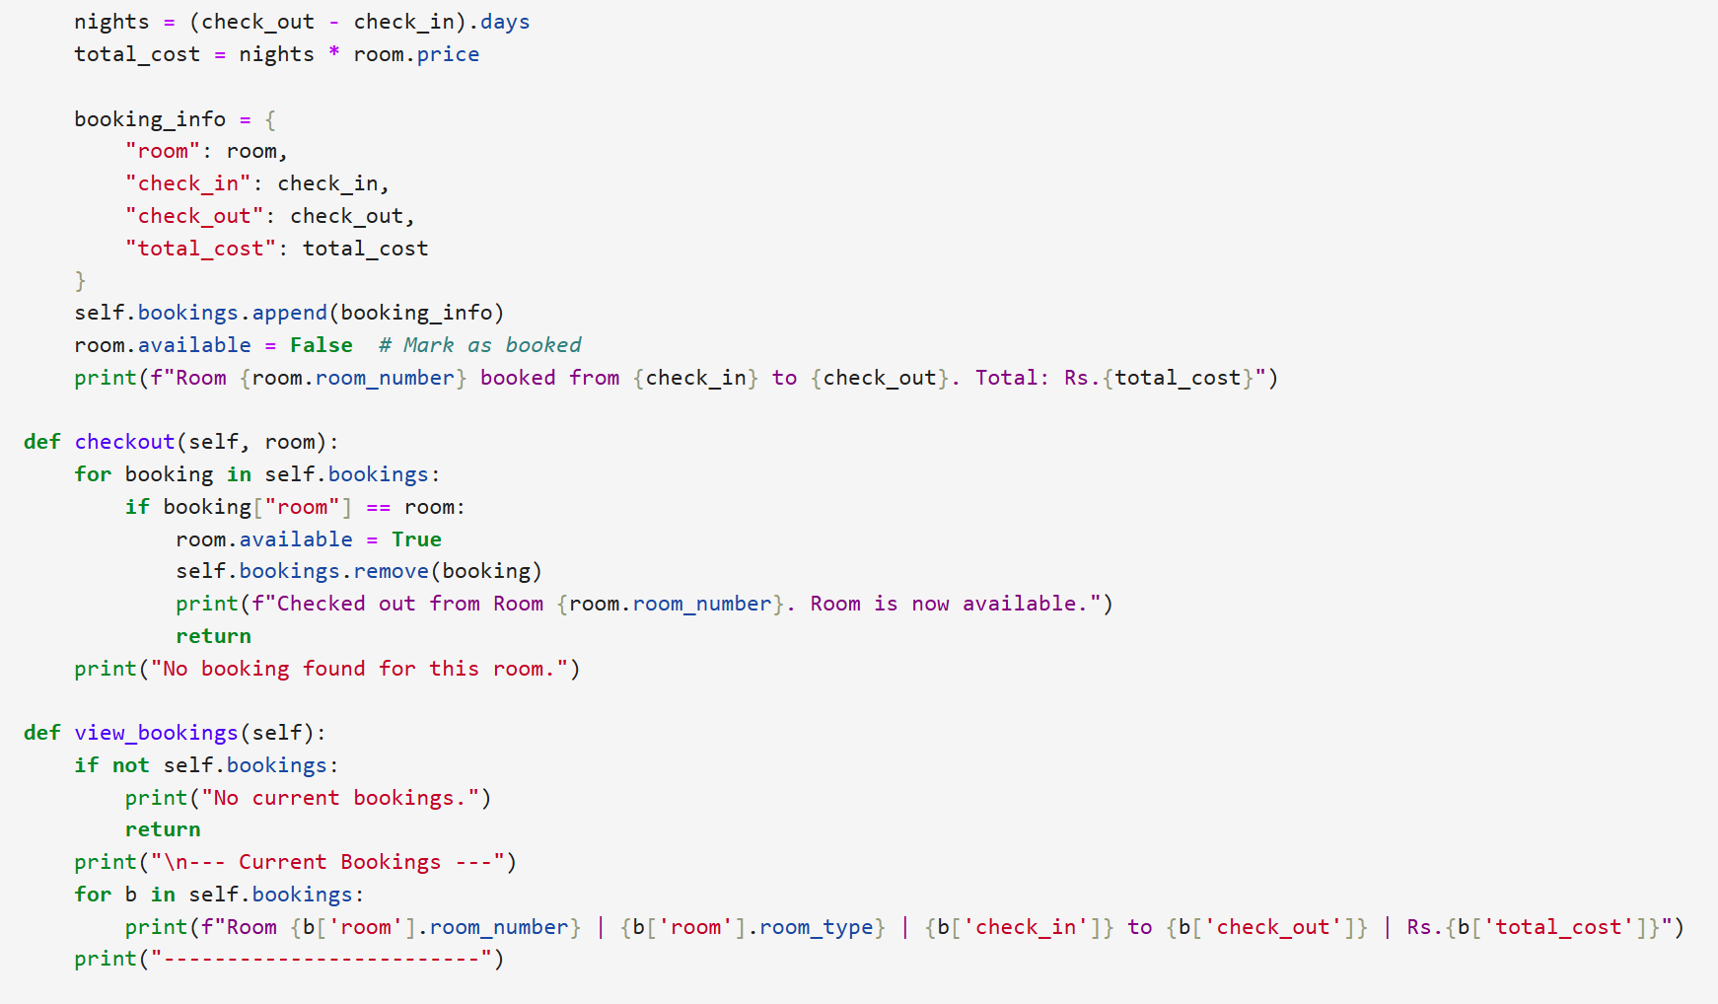

Output:
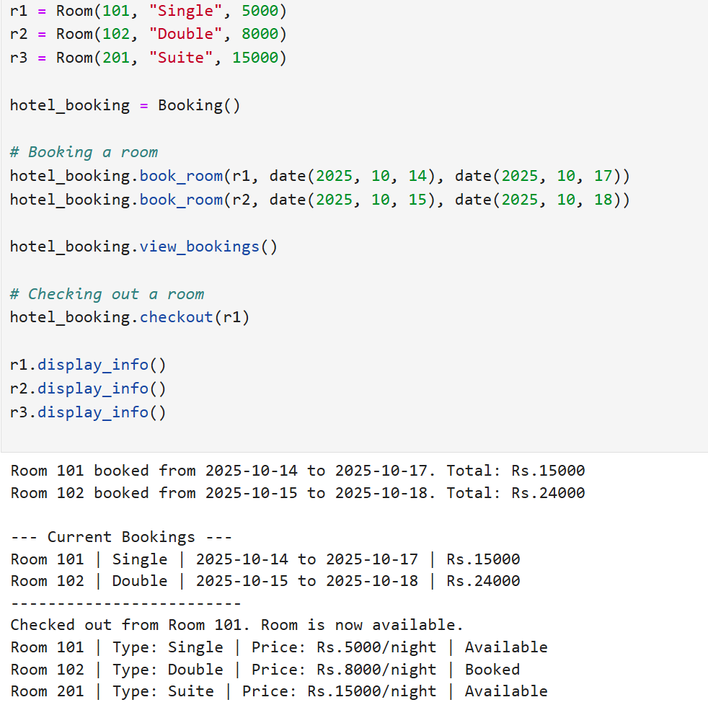

Q31. Course Registration System
Create Course classes (with code, name, credits, capacity).
Build a Student class that can register for courses.
Check for schedule conflicts and ensure credit limits aren't exceeded.
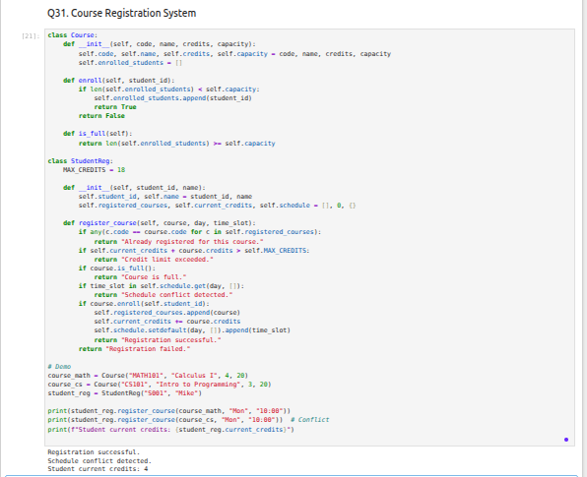

Q32. Inventory Management System
Design a Product class for inventory (ID, name, quantity, price, supplier).
Create an Inventory class to: track stock, add products, update quantities, generate low-stock alerts.
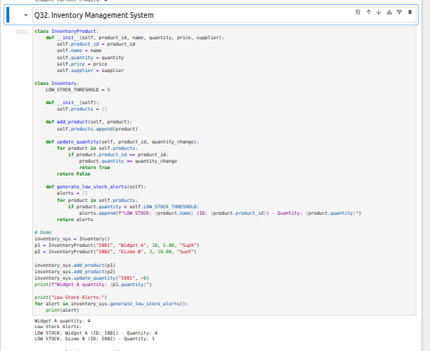

Q33. Movie Theater Booking System
Create Movie classes (title, genre, duration, showtimes).
Design a Theater class with seating arrangement.
Build a booking system to reserve seats and calculate ticket prices (standard/premium).
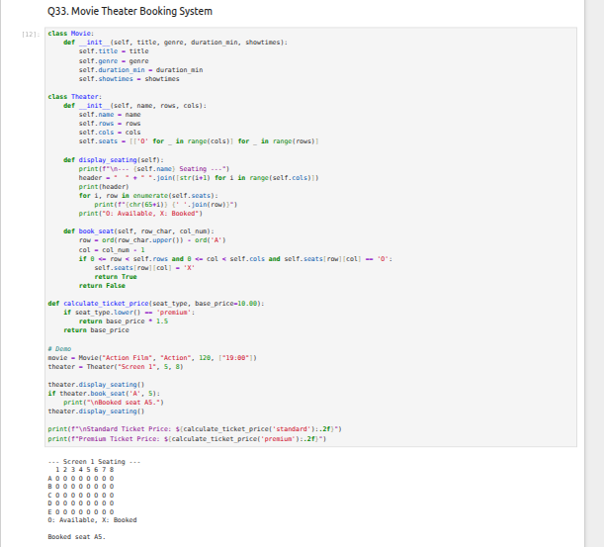

Q34. Gym Membership and Training System
Design a Member class with: personal details, membership type (basic/premium), attendance records.
Create a Trainer class.
Build a system to schedule training sessions between members and trainers.
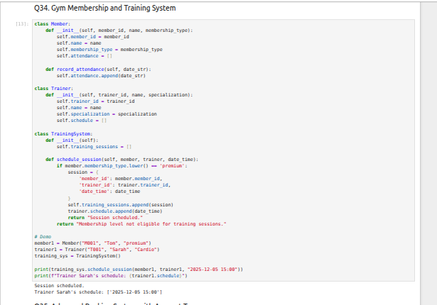

Q35. Advanced Banking System with Account Types
Extend the bank account system with SavingsAccount and CheckingAccount classes.
Each should have different interest rates and withdrawal rules.
Add functionality to transfer funds between accounts.
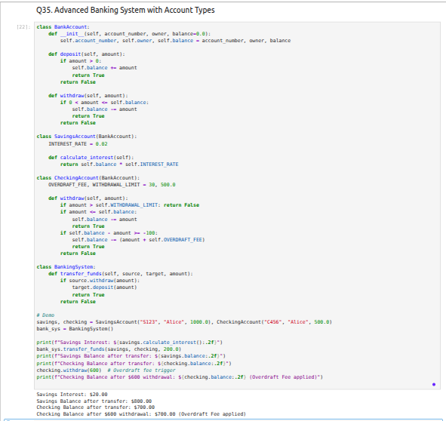

Q36. Pizza Ordering System
Create a Pizza class with: size, crust type, toppings.
Design an ordering system that calculates prices based on selections.
Allow custom pizza creation with various topping combinations.
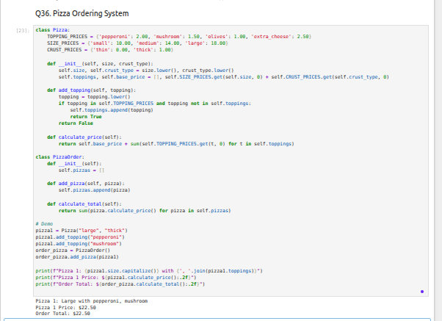

Q37. Car Manufacturing System
Design classes for Car (model, year, color, price) and CarManufacturer.
- The manufacturer can produce different car models with various features.
- Include quality control checks and production tracking.
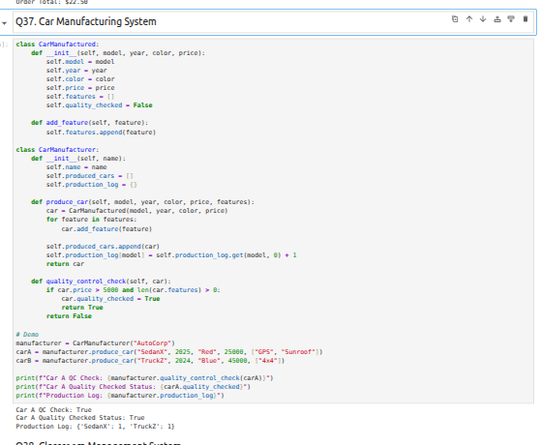

Q38. Classroom Management System
Create Teacher and Student classes.
- Design a Classroom class that manages: assignments, grades, attendance.
- Track student performance and generate class reports.
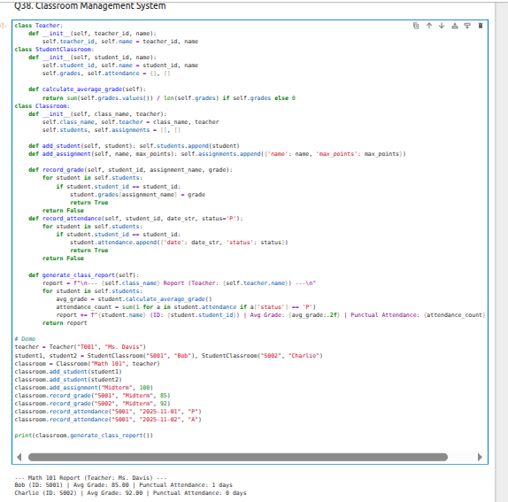

Q39. Flight Reservation System
Design Flight classes (flight number, destination, departure time, capacity).
- Create a Passenger class
- Build a booking system to reserve seats and manage passenger lists.
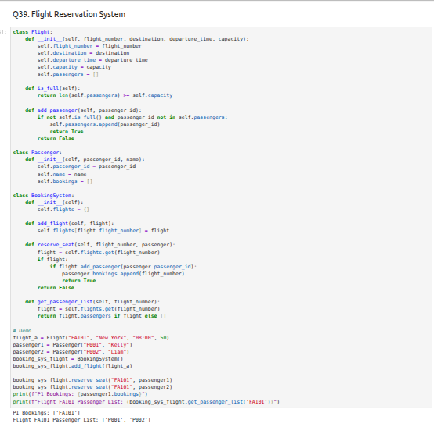

Q40. Smart Home Automation System
Create classes for Smart-Device (base class) and specific devices: Smart-Light, Thermostat, Security-Camera.
- Build a SmartHome class that can control all devices and create automation routines.
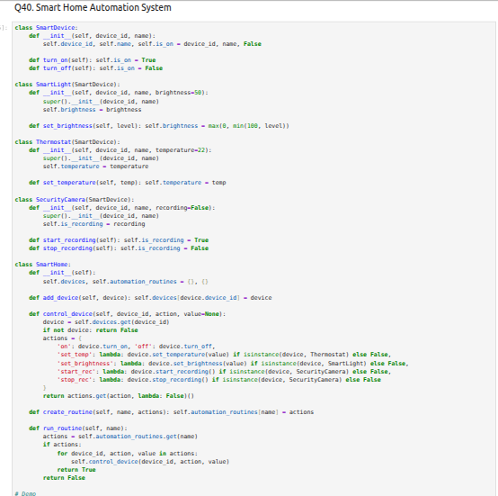
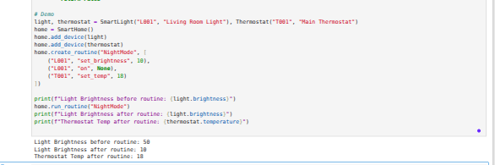46

LAB-3

“Numpy”

Question 41: Weekly Temperature Stats
Objective:
Analyze temperature data for 7 days using NumPy.
Input:
[21.1, 23.4, 19.8, 25.0, 26.5, 24.1, 22.0]
Tasks:
- Convert the list into a NumPy array.
- Find the average temperature.
- Find the maximum and minimum temperature.
- Compute the temperature difference (range).
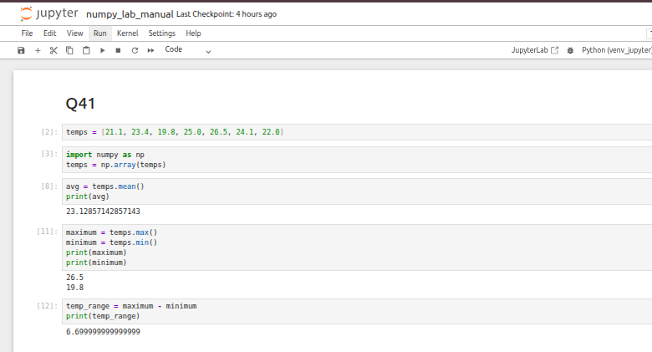

Question 42: Weekly Apple Sales
Objective:
Analyze apple sales data for 4 weeks using NumPy.
Input:
Week 1: [12, 15, 14, 10, 9, 8, 7]
Week 2: [11, 12, 13, 9, 5, 8, 6]
Week 3: [7, 9, 12, 10, 11, 13, 12]
Week 4: [10, 11, 12, 7, 8, 9, 11]
Tasks:
- Create a 4×7 NumPy array.
- Calculate weekly totals.
- Find the index of the highest sale day.
- Identify the week with the most sales.
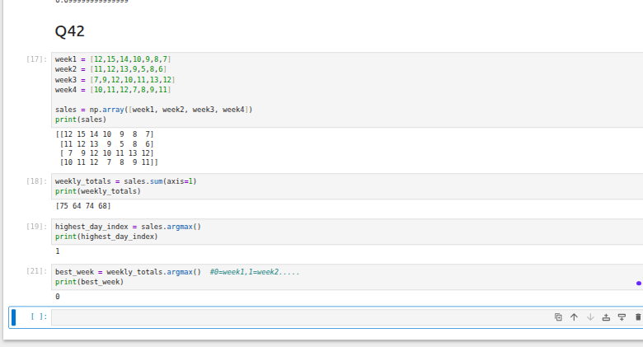

Question 43: Student Marks & Bonus
Objective:
Adjust marks and analyze student performance.
Input:
[56, 78, 45, 90, 88, 76, 59, 62]
Tasks:
- Convert the list into a NumPy array.
- Add 5 bonus marks to each student using broadcasting.
- Count students who scored more than 60 after bonus.
- Find the median and standard deviation.
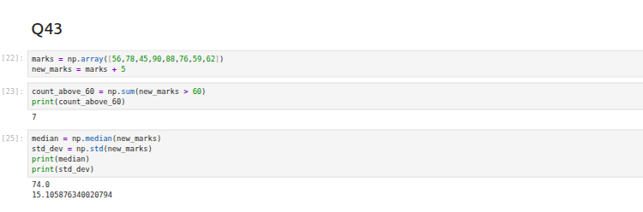

Question 44: Smartwatch Step Counts
Objective:
Analyze daily steps recorded over a month.
Tasks:
- Generate a random NumPy array of shape (30,) with values between 2000 and 15000.
- Reshape the array into a 5×6 matrix.
- Calculate weekly average steps.
- Identify the day with maximum steps.
- Count the number of days exceeding 10,000 steps.
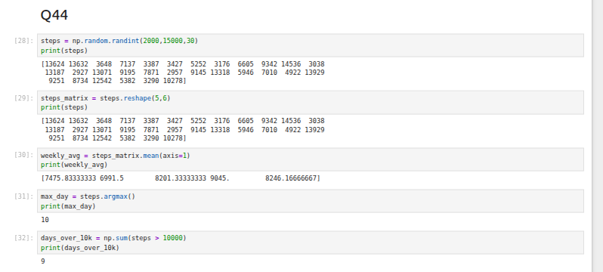

Question 45: Patient Heart Rates
Objective:
Analyze heart rate data for multiple patients.
Tasks:
- Create an integer array using np.random.randint(60,150,(10,4)).
- For each patient, compute the daily average.
- Identify abnormal readings greater than 120.
- Compute the overall maximum and minimum heart rates.
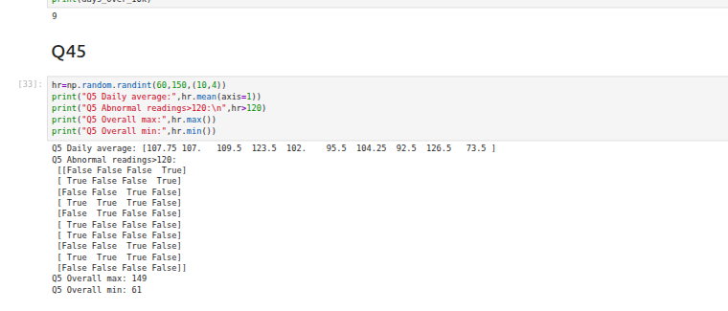

Question 46: Branch Monthly Sales Comparison
Objective:
Compare sales performance of two branches.
Input:
Branch A: [122, 135, 150, 160, 155, 140]
Branch B: [110, 130, 148, 165, 158, 145]
Tasks:
- Compute the difference between Branch A and Branch B.
- Calculate average monthly sales for each branch.
- Determine which branch performed better overall.
- Compute the correlation between the branches.
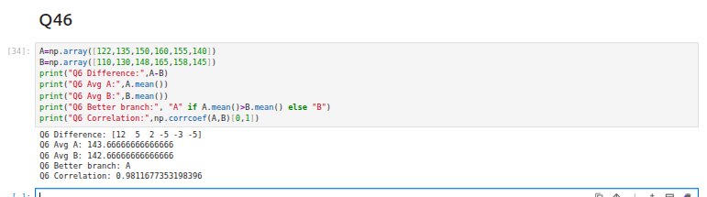

Question 47: Grayscale Image Transformation
Objective:
Normalize and transform pixel values in a grayscale image.
Input:
[[100, 120, 130, 90],
[80, 110, 140, 100],
[70, 90, 120, 130],
[110, 140, 150, 160]]
Tasks:
- Convert the list into a NumPy array.
- Normalize pixel values to range 0–1.
- Apply a transformation: new_pixel = pixel * 1.2.
- Clip values exceeding 255.
- Compute average brightness before and after transformation.
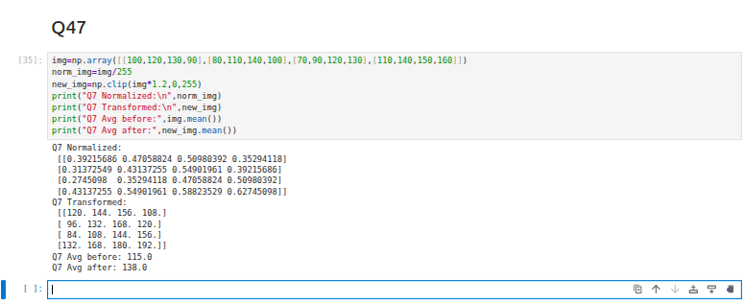

Question 48: Standardize Dataset
Objective:
Standardize a dataset of 100 samples with 4 features each.
Tasks:
- Generate a 100×4 matrix with values from 1 to 100.
- Standardize the dataset: x_scaled = (x - mean) / std.
- Compute column-wise mean and variance.
- Verify that column-wise mean ≈ 0 and variance ≈ 1.
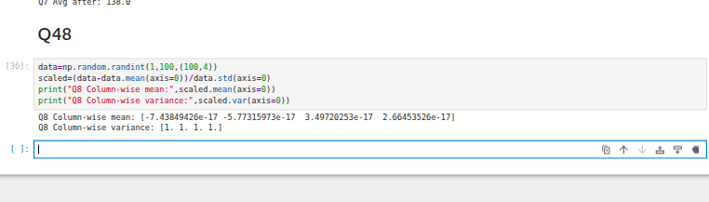

Question 49: Traffic Density Simulation
Objective:
Simulate traffic density recorded by 6 sensors over 24 hours.
Tasks:
- Generate an array of shape (24,6).
- Calculate hourly average traffic density.
- Identify the busiest sensor (highest total density).
- Apply a threshold: replace values above 50 with 50.
- Compute energy usage: energy = Σ(sensor-density × 0.5).
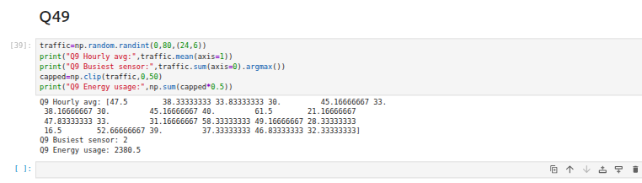

LAB-4

“Seaborn,Matplotlib,Sklearn”

Q-51Patient Stay Analysis (Healthcare)
You are given a dataset containing age, disease_type, and hospital_stay_days. Write a Python program using Seaborn to:
- Plot the distribution of hospital stay days
- Compare hospital stay across different disease types
- Identify which disease has the highest median stay

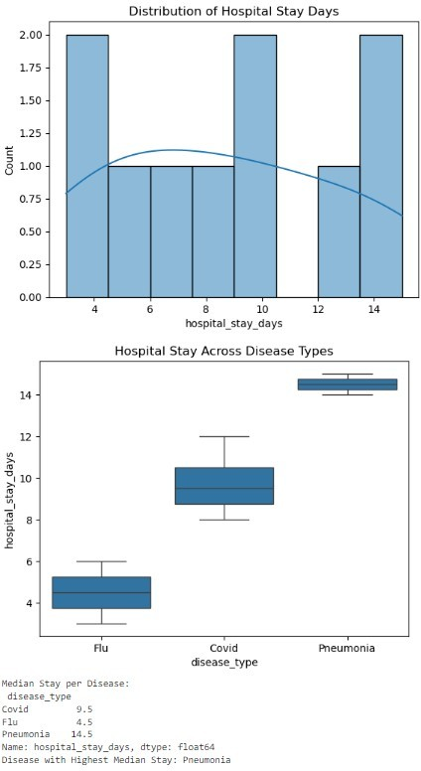
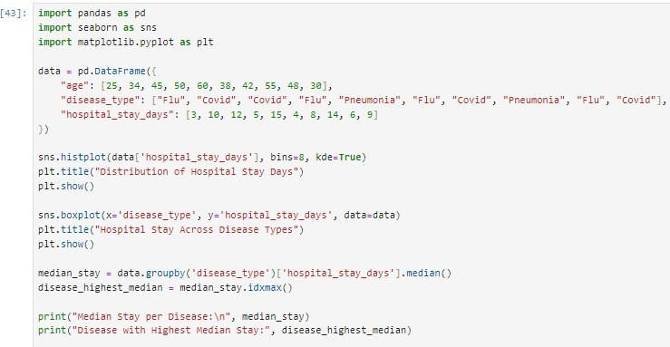

Q52. Sales Distribution Comparison (Business) A retail dataset contains region and monthly_sales. Write code to:
- Visualize sales distribution per region using Seaborn
- Detect regions with high sales variability
- Label the axes and add a title
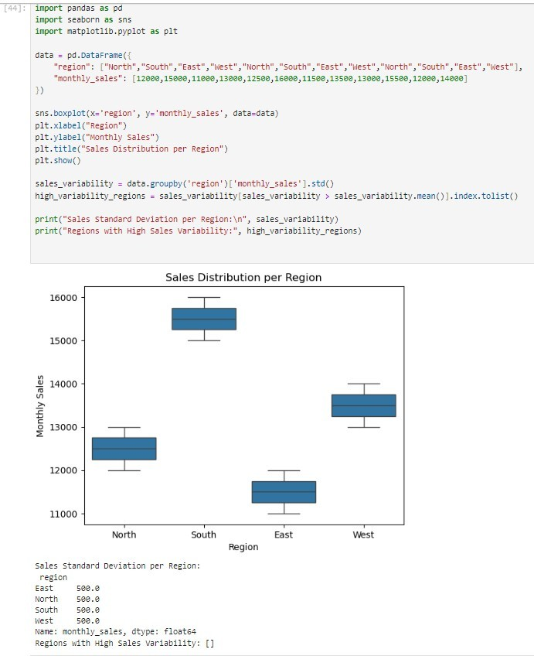

Q53. Student Performance Correlation (Education)
A dataset contains study_hours, attendance, and final_score. Using Seaborn:
- Create a pair plot
- Plot a correlation heatmap
- Interpret which feature most affects the final score

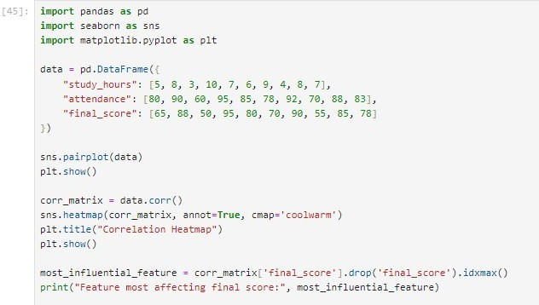

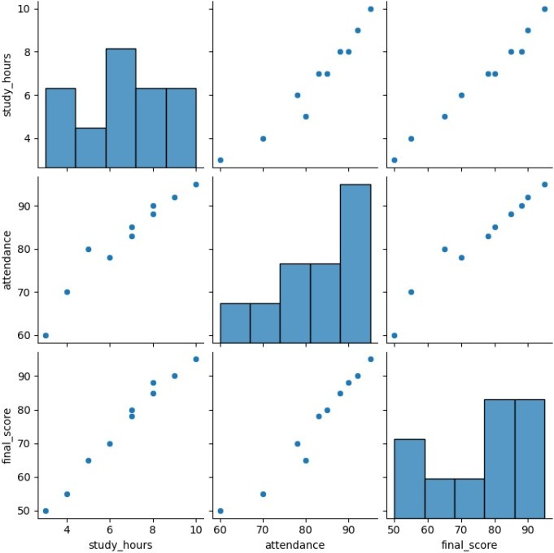

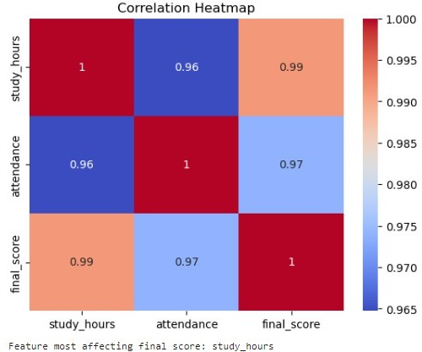

Q54. Customer Segmentation Visualization
Customer data includes age, annual_income, and spending_score. Write a program to:
- Visualize relationships using Seaborn scatter plots
- Color-code points based on spending score
- Identify potential customer segments visually

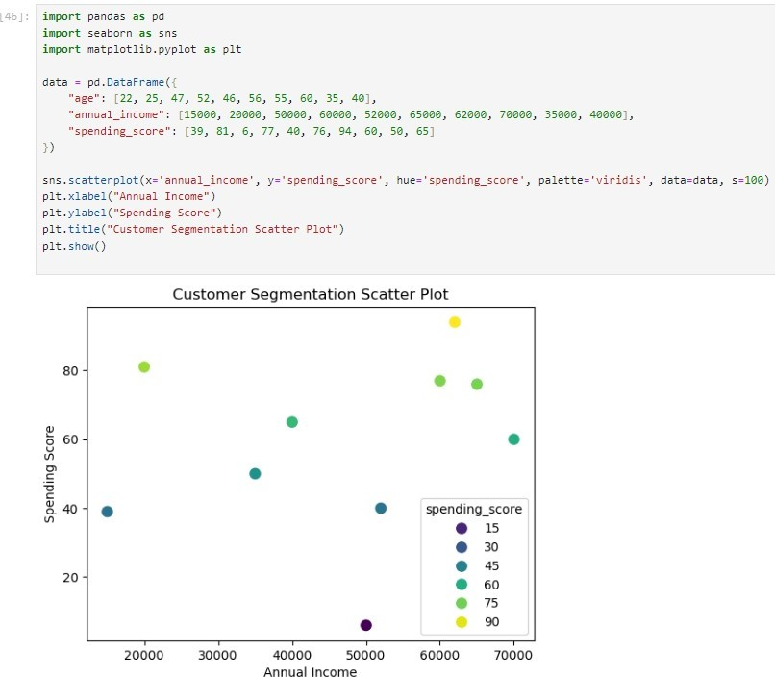

Q55. Model Result Visualization
You trained a classifier and obtained y_true and y_pred. Write code using Seaborn to:
- Plot a confusion matrix heatmap
- Add annotations and color bar
- Clearly label predicted vs actual classes

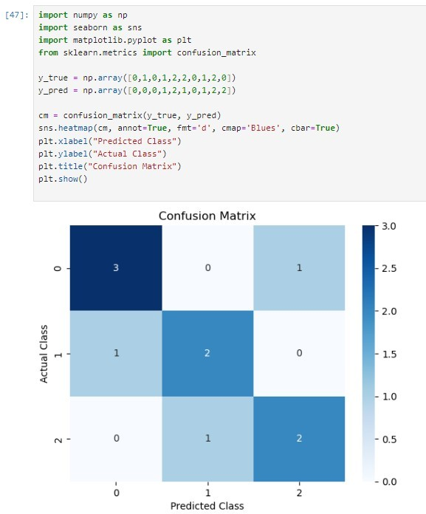

Question # 16: Create a `Pizza` class with size, crust type, and toppings. Design an ordering system that calculates prices based on selections and allows custom pizza creation with various topping combinations.
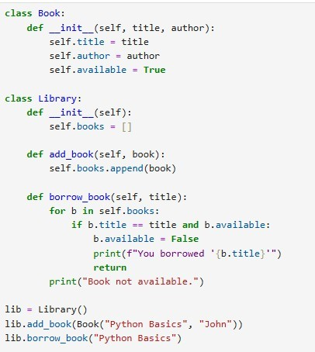

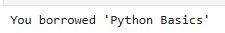

Question # 17: Design classes for `Car` (model, year, color, price) and `CarManufacturer` that can produce different car models with various features. Include quality control checks and production tracking.

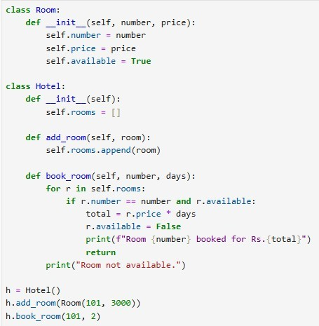

Question # 18: Create `Teacher` and `Student` classes, and a `Classroom` class that manages assignments, grades, and attendance. Implement functionality to track student performance and generate class reports.

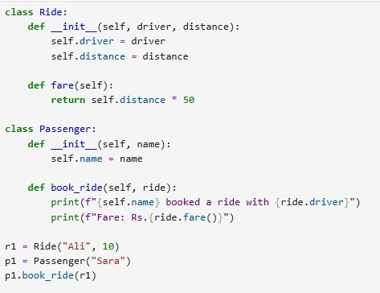

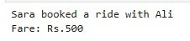

Question # 19: Design `Flight` classes (flight number, destination, departure time, capacity) and a `Passenger` class. Create a booking system that reserves seats and manages passenger manifests.
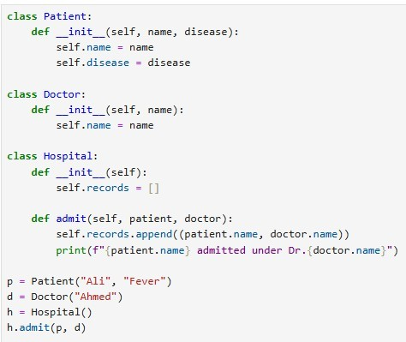

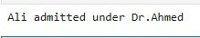

Question # 20: Create classes for `SmartDevice` (base class) and specific devices like

`SmartLight`, `Thermostat`, and `SecurityCamera`. Implement a `SmartHome` class that can control all devices and create automation routines.

